**1. Download Setup SQL Server**

The first step is to download and install SQL Server

You can get it from this link.

<https://www.microsoft.com/en-us/sql-server/sql-server-downloads>

It’s necessary to have some knowledge of databases before get into SQL Server Reporting Services (SSRS).

**2. Setup SQL Server Management Studio**

Download and install SQL Server Management Studio (SSMS). This is the application you can use to manage databases.

You can download it from this link – <https://docs.microsoft.com/sql/ssms/download-sql-server-management-studio-ssms>

[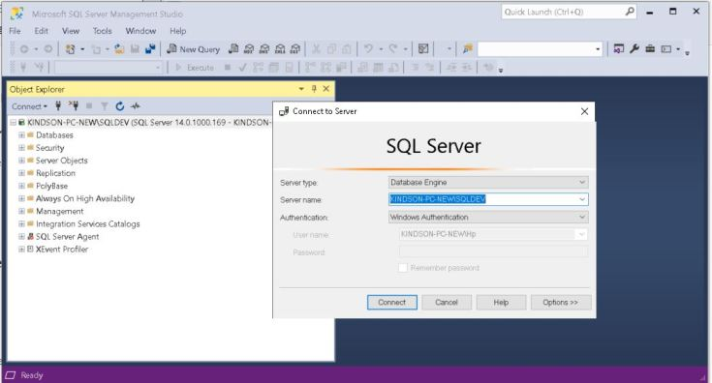](https://i0.wp.com/kindsonthegenius.com/mssql/wp-content/uploads/2022/05/SQL-Server-Management-Studio.jpg?ssl=1)SQL Server Management Studio

**3. Install SQL Server Reporting Services**

Now, you must install SQL Server Reporting Services.

You can download it from here – <https://www.microsoft.com/en-us/download/details.aspx?id=100122>

Once you download it,  just go ahead to install it. Then you will have the Report Server Configuration Manager.

After the installation, you can open the configuration manager as shown below:

[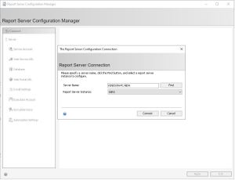](https://i0.wp.com/kindsonthegenius.com/mssql/wp-content/uploads/2022/05/SSRS.jpg?ssl=1)SSRS Server Configuration Manager

**4. Configure SQL Server Reporting Services (SSRS)**

When you open configuration manager, click on Connect.  The follow the steps below to complete the configuration.

**1.  Configure Web Service URL**. Click on Web Service URL link on the left and then click on Apply as shown below:

[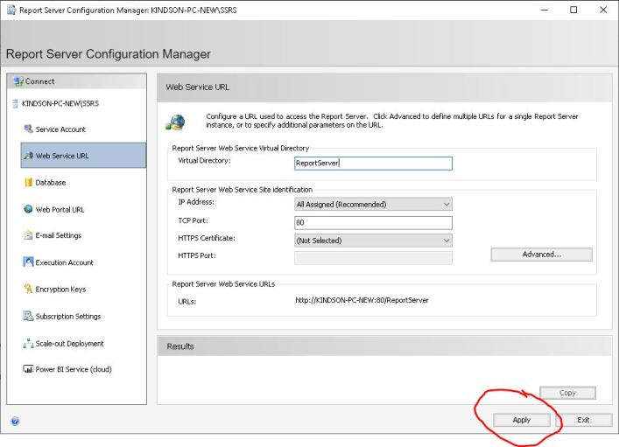](https://i0.wp.com/kindsonthegenius.com/mssql/wp-content/uploads/2022/05/Apply-Web-Service-URL.jpg?ssl=1)Web Service URL Configuration

**2. Configure the Database:** Click on the Database tab on the left and follow the instructions to set up the Report Server Database.

[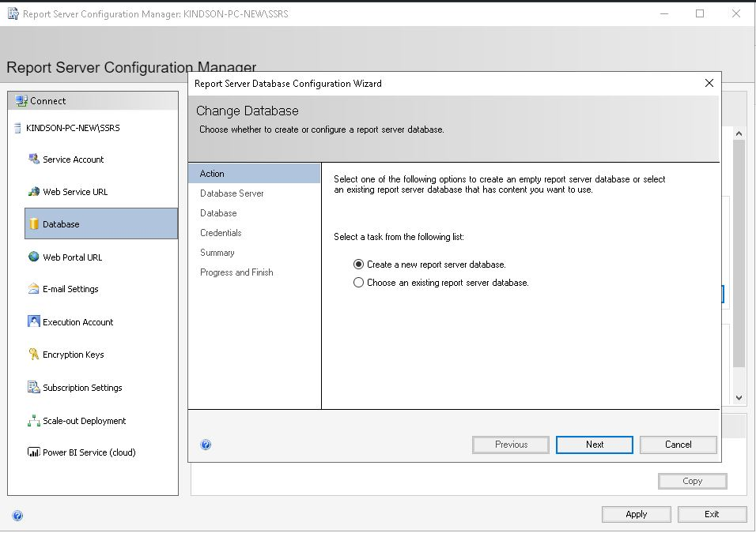](https://i0.wp.com/kindsonthegenius.com/mssql/wp-content/uploads/2022/05/Database-Tab.jpg?ssl=1)Database Configuration

**3. Configure Web Portal URL** – Click on the Web Portal URL and just click on Apply as shown below:

[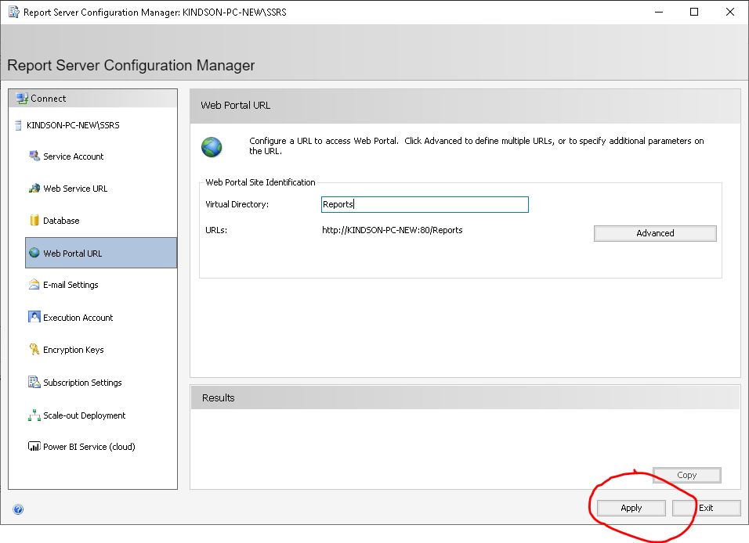](https://i0.wp.com/kindsonthegenius.com/mssql/wp-content/uploads/2022/05/Web-Portal-URL.jpg?ssl=1)Configure Web Portal URL

At this point, the SSRS Configuration is complete and you can exit.

**5. Connect to SSRS and Register a Report Server**

To use reporting services, you need to register the server in SQL Server Management studio. Open Management Studio.

Goto View > Registered Servers.

Then follow the instruction to registers  the reporting server you earlier configured.

[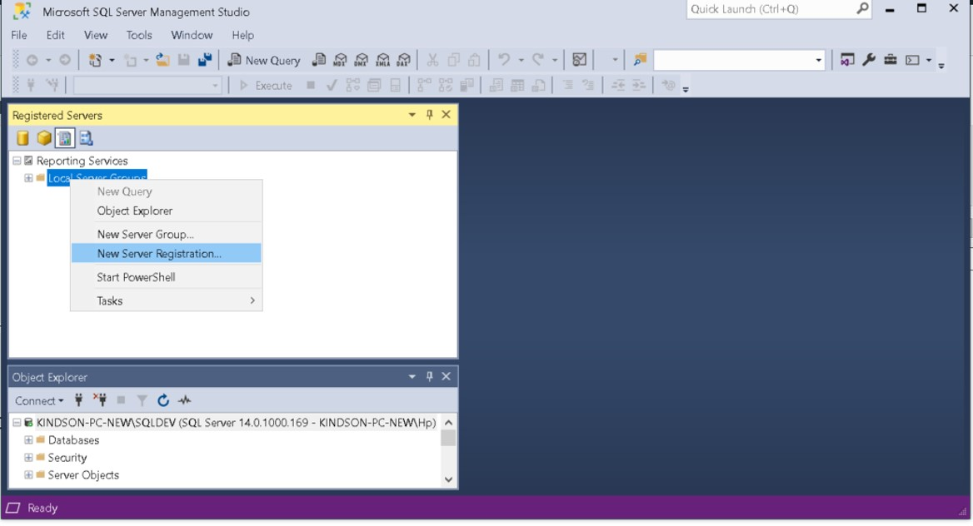](https://i0.wp.com/kindsonthegenius.com/mssql/wp-content/uploads/2022/05/Register-Report-Server.jpg?ssl=1)Register Report Server